Linking Spatiotemporal Changes in Mangrove Species Composition and Restoration Outcomes to Canopy Height Using Multi-Source Remote Sensing
Zachary Afifª, Uday Pimple^{b*}, Dario Simonetti^{c}, Asamaporn Sitthi^{f}, Uta Berger^{g}, Valéry Gond^{g},
ª XXXXXXX, Indonesia
^{b} The Joint Graduate School of Energy and Environment and Centre of Excellence on Energy Technology and Environment, King Mongkut's University of Technology Thonburi, Bangkok 10140, Thailand
^{b} GIS and Remote Sensing Consultant, 21059, Varese, Italy; gis.dario.simonetti@gmail.com
^{e} Srinakharinwirot University; as.sitthi@gmail.com ; asamaporn@g.swu.ac.th
^{g}Institute of Forest Growth and Computer Sciences, Technische Universität Dresden, Tharandt, Germany; uta.berger@tu-dresden.de
^{f}CIRAD, UPR Forests and Societies (F&S), Campus International de Baillarguet, Montpellier, France; valery.gond@cirad.fr
* Correspondence: upimple@gmail.com; uday.pim@kmutt.ac.th Tel.: +66-2-872-9014 (ext. 4112)

Abstract:

Introduction
Mangrove forests are one of the most valuable and productive ecosystems, forming a critical interface between land and sea. They provide numerous ecosystem services, including serving as significant carbon sinks storing three to five times more carbon than terrestrial forests (Alongi, 2012), as well as supporting biodiversity and protecting coastlines. The Indo-West-Pacific region including Southeast Asia are one of the highest biodiversity regions responsible for accommodating about 62 species, compared to the Atlantic-East Pacific region (only 12; Duke et al., 1998; Spalding, et al., 2010; Tomlinson, 2016). The species diversity is driven by local environmental settings and responsible for structural complexity and carbon sequestration potential (Pimple et al., 2022b; Sitthi et al., 2025).
While the global rate of mangrove losses has decreased, countries in Southeast Asia countries like the Philippines, Cambodia, Indonesia, Myanmar, Malaysia continue to experience high losses (Bunting et al., 2023; Friess et al., 2019; Gandhi and Jones, 2019; Goldberg et al., 2020). Although awareness have expanded restoration efforts across the region (Sitthi et al., 2025; Song et al., 2023), many focus on monoculture plantations without an adequate site assessment or consideration of ecological principles (Pimple et al., 2022a, 2020; Sitthi et al., 2025). As a result, these areas often show reduced ecological functions, altered species composition (monoculture) and simplified forest structure (Asaeda et al., 2016; Pimple et al., 2023, 2022a). Understanding the baseline of mangrove species diversity, restoration outcomes and their structural dynamics remains limited, with only a few localized studies (Pimple et al., 2025, 2022a, 2020). Since canopy height can be considered as one of the key indicators of forest maturity and structural complexity (Simard et al., 2019), linking it with species composition and restoration history provides a direct way to assess the outcome of conservation interventions, structural complexity and ecological functions over a period.
Canopy height serves as a measurable indicator for restoration success and detecting natural disturbances and recovery caused by storms, tsunamis or lightning strikes. Reliable estimation of canopy height are fundamental for assessing above-ground biomass, vertical complexity, and habitat quality (Alexander et al., 2018; Asner et al., 2010; Goetz et al., 2010; Hill and Hinsley, 2015; Li et al., 2020). However, spatiotemporal analyses of canopy height dynamics remain scarce, as most studies rely on single-date observations (Zhen et al., 2024). Traditional field-based measurements are limited in scale due to high cost, accessibility challenges, and time requirements. Remote sensing technologies such as Landsat, Sentinel-1 and-2, LiDAR, ICEsat-1 and 2 and GEDI (Ecosystems Dynamics Investigation (GEDI); Land, Vegetation, and Ice Sensor (LVIS); and its predecessor although allow large scale species diversity distributions, success of restoration, and structural attributes (Otero et al., 2019; Pimple et al., 2025) (Jia et al., 2025) (Neuenschwander et al., 2020) (Li et al., 2020) (Nandy et al., 2021).
The integration of Sentinel-1 and-2 SDGSAT-1 MII, and UAV-LiDAR showed potential for canopy height measurements in mangrove forests (Jia et al., 2025). The recently launched ICESat-2 demonstrates promising results for terrain and canopy height monitoring in forested ecosystems, including boreal and Mountainous forest (Neuenschwander et al., 2020) (Li et al., 2020), as well as above-ground biomass mapping (Nandy et al., 2021). However, its application in mangroves studies remains limited. Yu et al. (2022) evaluated ICESat-2 for canopy height retrievals. Besides the capacity of ICESat-2 to use a green wavelength (532 nm) that allows simultaneous measurement of terrain and vegetation and is well-suited for mapping canopy height in flooded and wetland areas. The above studies were restricted to mangrove extent, without addressing spatiotemporal dynamics of species diversity or long-term restoration outcomes.
The growing availability of medium- and high-resolution imagery such as Landsat Sentinel-1 SAR, Sentinel-2 MSI imagery, and LiDAR technologies, combined with cloud-computing platforms like Google Earth Engine (GEE) and advanced machine learning capabilities, further strengthens data processing and predictive modeling for canopy height estimation. These models can integrate LiDAR-derived variables with satellite imagery features, including spectral reflectance, spectral indices, texture metrics, and other derived parameters, improving the accuracy and spatial coverage of canopy height predictions (Li et al., 2020). Additionally, incorporating long-term spatiotemporal dynamics of species distribution and rehabilitation baselines can help overcome the limitations of single-date LiDAR observations, providing a more comprehensive assessment of mangrove structural and ecological changes (Pimple et al., 2025).
Building on these recent advances, this study addresses the knowledge gap of how canopy height derived from ICESat-2, GEDI, and satellite imagery can be used to assess mangrove structural dynamics and evaluate restoration success at a landscape scale, in relation to long-term spatiotemporal patterns of species diversity and restoration outcomes. By integrating these remote sensing data with existing baseline field inventory, species and rehabilitation maps, we can link canopy height measurements to surface elevation, species composition, stand structure, and historical restoration interventions. To address this question, the specific objectives are to: (1) map and analyse mangrove canopy height using remote sensing in combination with existing baseline data; (2) assess rehabilitated and natural stands to evaluate restoration success based on height and structural patterns; and (3) explore species-level height differences to understand how species composition influences forest structure and restoration outcomes.
2 Study area and dataset

2.1 Study area
The study area is located in Trat Province, Thailand (12.21° N, 102.61° E). The area consists of various mangrove conditions such as natural mangrove, rehabilitated mangrove, and regenerated mangrove. The study site was selected as it had a vast area of mangrove forests, which covers approximately 106 km2, with a large rehabilitated mangrove area adjacent to natural mangrove. Previously, the area was subject to large-scale rehabilitation efforts that were conducted without a proper site assessment using a monoculture of Rhizophoraceae and several degraded lands have undergone a natural regeneration. In addition, the area also had a zone of mangrove forest that was once degraded by shrimp farming and agriculture (Pimple et al., 2025, 2020). Importantly, the site contains detailed baseline data on species distribution and restoration from 1987 to 2022 (Pimple et al., 2025, 2022a). These data provide a robust foundation for assessing the canopy height with respect to species community assemblages and the success of restoration interventions over time.

The study area supports a complex mangrove ecosystem with over 19 genera existing within the region. The currently identified species are Avicennia alba, Avicennia marina, Avicennia officinalis, Bruguiera cylindrica, Bruguiera gymnorhiza, Bruguiera hainesii, Bruguiera sexangula, Ceriops tagal, Excoecaria agallocha, Heritiera littoralis, Intsia bijuga, Lumnitzera littorea, Lumnitzera racemosa, Rhizophora apiculata, Rhizophora mucronata, Sonneratia alba, Sonneratia ovata, Xylocarpus granatum, and Xylocarpus moluccensis (Pimple et al., 2025, 2020). This existing field data will be used in this study.

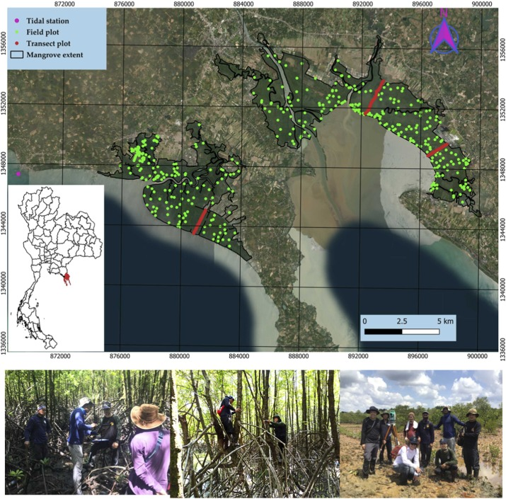
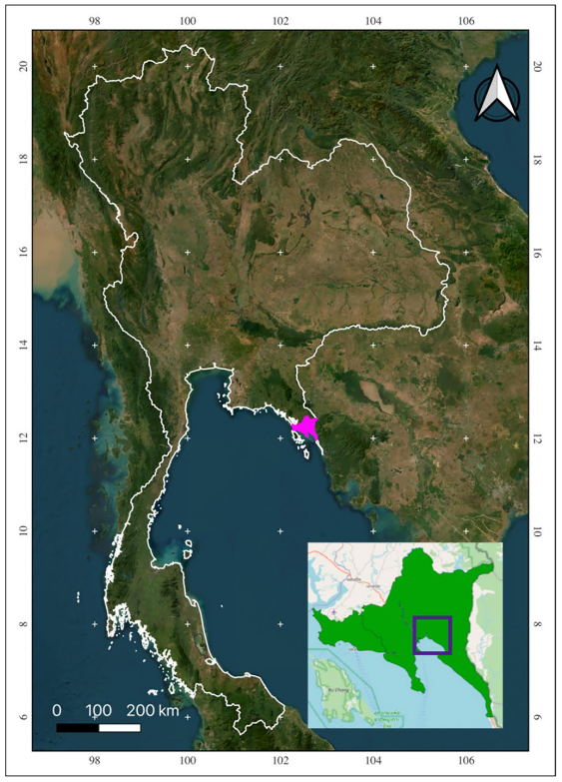

Figure 2. The location of Study area at Trat Province, Thailand (1) existing field data 257 plot at 10 m x 10 m; (2) green dots are spatial distribution of field data; (3) red dots are the transect plot with inclusion of microtopography measurements across sea to land gradient.

2.2 Dataset
2.2.1 Sentinel-1 SAR and-2 MSI Composites
The study utilized Sentinel-1 SAR with dual polarization of C-band obtained from Google Earth Engine (GEE; 2020-2022) collection. The imagery has been preprocessed border noise correction, thermal noise removal, radiometric calibration, orthorectification, and LEE speckle filtering (Mullissa et al., 2021; Slagter et al., 2020). The terrain normalization was excluded due to uncertainties associated with global Shuttle Radar Topographic Mission and ASTER Global DEM elevation data in mangrove forests (Pimple et al., 2025).
Sentinel-2 data contain images of 13 UNIT 16 spectral bands, representing the TOA reflectance for the period 2020 -2022 was sourced from GEE collection. To handle the potential unreliability of Sentinel-2A cloud mask, cloud and shadow removal was performed using knowledge-based tested rules (Pimple et al., 2025; Simonetti et al., 2021; Zhang et al., 2018). Only blue, green, red, NIR, SWIR-1, and SWIR-2 bands were used; SWIR-1 and SWIR-2 bands were resampled at 10 m resolution using nearest neighbour transformation.

Only low tide images of Sentinel-1 SAR and-2 MSI were considered to avoid the effect of periodic tidal inundation effect (Pimple et al., 2025; Rogers et al., 2017). A median composite collection was computed to reduce the short-term tidal effects, seasonal variability, and noise from outliers, ensuring consistency and quality of pixels (Sagar et al., 2017).

Then, we calculated several spectral indices and radar indices as shown in table 1. were calculated.

Table 1. Spectral and Radar Indices used for modelling

Indices | Source | Formula | Reference
NDVI
GNDVI
SAVI
NDII

2.2.2 Field Inventory data
To achieve landscape scale species heterogeneity areas, a stratified random sampling approach was used. In total, 257 plots were collected across the landscape, including three transects perpendicular to sea to land gradient. In addition, microtopography was also being recorded across these transects using a total station survey method.
All data collection was performed at 10 x 10 m plot size, where species diameter at breast height (DBH), height, and tree count were recorded using tapes and a clinometer (Pimple et al., 2025, 2022a).
2.2.3 Species distribution and rehabilitation baseline data

Species distribution and rehabilitation baseline was derived from Pimple et al. (2025), which provides spatially explicit data on mangrove species composition, restoration history, and stand development stages across Trat Province, Thailand. The dataset was developed using a combination of Landsat (1987–2022), Sentinel-1 SAR, and Sentinel-2 MSI imagery integrated SARMA framework. This dataset served as the foundation for linking canopy height variation to species composition and rehabilitation type.

2.2.4 ICESat-2
The Ice, Cloud, and Land Elevation Satellite-2 (ICESat-2) is a second-generation spaceborne laser altimeter that uses multibeam photon-counting LiDAR technology. Unlike traditional altimeters operating in Near Infrared wavelength (1064 nm) range, the ICESat-2 operates at green wavelength (532 nm), allowing it to penetrate shallow water surfaces (Mandlburger et al., 2013; Parrish et al., 2019; Studinger et al., 2024) and capture both vegetation and terrain elevations, a specification particularly useful for mangrove tidal conditions.
ICESat-2 provides 21 standard data products (ATL00–ATL21) derived from its Advanced Topographic Laser Altimeter System (ATLAS). For this study, the ATL08 product was used, containing precise measurements of latitude, longitude, terrain, and vegetarian height.
Further processing was carried out using the SlideRule API, a public web service processing framework that enables on-demand extraction and filtering of ICESat-2 data. Photon-level information was processed through Photon Research and Analysis Library (PhoREAL) tools (Amy L. Neuenschwander and Lori A. Magruder, 2023) to classify terrain and vegetation photons and converted to common geospatial data formats. For this study, the ATL08 product was used, containing precise measurements of latitude, longitude, terrain, and vegetation height metrics. Processing was carried out using the SlideRule API, a public web service processing framework that enables on-demand extraction, data filtering, and conversion to common geospatial data formats.
Then, we apply filter to ensure the data quality based on the photon confidence parameter (parameter cnf) and photon quality indicator (paratemer quality_ph) that determine photon shots quality based on possible saturated conditions and/or instrument effect. We set the the parameters to high (4) and nominal (0) respectively to get the highest quality photon shots. Last, we ensure only vegetation object was in our dataset by filtering out points with height below 2 meter and above 25 meter.

Last filter of the data is to ensure the ICESat-2 data have values aligned with the benchmark global mangrove height (Tolan et al., 2024). This step is done to ensure the dataset is free from systematic errors from the acquisition process by spaceborne lidar. We filter out data with benchmark CHM that has height below 2 meter and difference with ICESat canopy height more than 5 meter.

3. Methodology

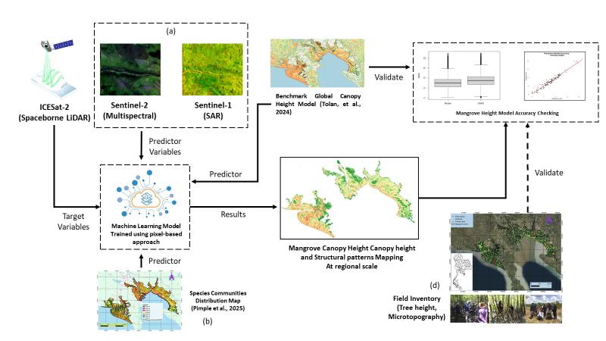

Figure 2. Diagram of Methodology adapted to map the mangrove canopy height

  - Machine Learning modelling
Dataset was splitted with 70:30 proportion for training and testing dataset. The splitting was done by using stratified random sampling. Stratified random sampling was done to ensure well-balanced representative sample from each species community. This sampling method was done by preserving the same proportion of each species association in the train-test data set (70% training, 30% testing).

Predictive Modelling was done by using random forest algorithm. The process was done using caret package in R so that we can have a model with the best tuning parameter. The model was then tested to predict the test dataset (30%) to know the model's performance. The model performance was evaluated based on root mean square error (RMSE), Mean Absolute Error (MAE), and Mean Absolute Percentage Error (MAPE) metrics.

      - Full Coverage Prediction
The predictive model was then used to predict the full coverage of the mangrove extent in the study area.

      - Model Validation
Model validation was done by comparing the data to ground measurement data. This validation gives the final model accuracy. The same as evaluating model performance, we use root mean square error (RMSE), Mean Absolute Error (MAE), and Mean Absolute Percentage Error (MAPE) metrics. If needed we also can do model validation against other canopy height model (Tolan’s, Simard’s, Krause’s).

Results
  - Height Model Development

  - Accuracy Check against ground truth data and benchmark model

Discussion
However, ICESat-2 data also have their own limitations. The main limitation is the discrete availability of the data as the ICESat-2 mission is a sampling mission (Markus et al., 2017), thus it does not provide a full coverage data.

2.2.4 Global Forest Canopy Height Model
Global forest canopy height was used as both a predictor and a baseline for this study. The global canopy height used was produced from (Tolan et al., 2024), which utilized very high resolution RGB imagery that was trained into LiDAR data (aerial and spaceborne) using self-supervised model and convolutional network.

Conclusion

Acknowledgments
We would like to express our sincere gratitude to the Department of Marine and Coastal Resources, Trat office staff Mr. Anuchit Jaikuea, Mr. Ruchakorn Tanasomboonpan, and Mr. Thanakrit Bunkoed for their support and active participation during the all-species diversity field surveys for this project.
Our thanks extend to the Royal Forest Department staff Mr. Kraiwut Siri-on, Ms. Napaporn Kao-min, Ms. Radklao Au-ngern, Mr. Ridthichi Namsri, Mr. Nitiwut Nilawong, and Mr. Surasit Maneetab for their valuable assistance during the ground elevation surveys. Need to add more names
We thank the Marine Department (Bangkok office), Ministry of Transport, Thailand, for providing essential tidal data.

Funding

This research was funded by the Southeast Asia-Europe Joint Funding Scheme for Research and Innovation, 2018–2022 as a part of a project entitled, “Monitoring and optimizing the design quality of mangrove restoration towards a sustainable coastal ecosystem management in Thailand and Mekong Delta of Vietnam” [Project code:- Thailand (NSTDA): P-18–51184, France (ANR): N0 ANR-17-ASIE-0003–01, Germany (BMBF): 01DQ18004] and “Monitoring and optimization of mangrove restoration for sustainable management of coastal ecosystems in Southeast Asia (2023–2026)” [the National Science, Research and Innovation Fund (NSRF) via the Program Management Unit for Human Resources & Institutional Development, Research and Innovation (PMU-B), Thailand: B48G660110 and Germany (BMBF): 01DP23002].

References

Alongi, D.M., 2012. Carbon sequestration in mangrove forests. Carbon Manag. 3, 313–322. https://doi.org/10.4155/cmt.12.20
Amy L. Neuenschwander, Lori A. Magruder, 2023. PhoREAL: increasing spatial and temporal data accessibly of ICESat-2 through open-source Python repository. Presented at the Proc.SPIE, p. 125370E. https://doi.org/10.1117/12.2667098
Asaeda, T., Barnuevo, A., Sanjaya, K., Fortes, M.D., Kanesaka, Y., Wolanski, E., 2016. Mangrove plantation over a limestone reef - Good for the ecology? Estuar. Coast. Shelf Sci. 173, 57–64. https://doi.org/10.1016/j.ecss.2016.02.017
Bunting, P., Hilarides, L., Rosenqvist, A., Lucas, R.M., Kuto, E., Gueye, Y., Ndiaye, L., 2023. Global Mangrove Watch: Monthly Alerts of Mangrove Loss for Africa. Remote Sens. 15, 2050. https://doi.org/10.3390/rs15082050
Duke, N.C., Ball, M.C., Ellison, J.C., 1998. Factors influencing biodiversity and distributional gradients in mangroves. Glob. Ecol. Biogeogr. Lett. 7, 27–47. https://doi.org/10.2307/2997695
Friess, D.A., Rogers, K., Lovelock, C.E., Krauss, K.W., Hamilton, S.E., Lee, S.Y., Lucas, R., Primavera, J., Rajkaran, A., Shi, S., 2019. The State of the World’s Mangrove Forests: Past, Present, and Future. Annu. Rev. Environ. Resour. 44, 89–115. https://doi.org/10.1146/annurev-environ-101718-033302
Gandhi, S., Jones, T.G., 2019. Identifying Mangrove Deforestation Hotspots in South Asia, Southeast Asia and Asia-Pacific. Remote Sens. 11, 728. https://doi.org/10.3390/rs11060728
Goldberg, L., Lagomasino, D., Thomas, N., Fatoyinbo, T., 2020. Global declines in human‐driven mangrove loss. Glob. Change Biol. 26, 5844–5855. https://doi.org/10.1111/gcb.15275
Jia, M., Zhang, R., Zhao, C., Zhou, Y., Ren, C., Mao, D., Li, H., Sun, G., Zhang, H., Yu, W., Wang, Z., Wang, Y., 2025. Synergistic estimation of mangrove canopy height across coastal China: Integrating SDGSAT-1 multispectral data with Sentinel-1/2 time-series imagery. Remote Sens. Environ. 323, 114719. https://doi.org/10.1016/j.rse.2025.114719
Mandlburger, G., Pfennigbauer, M., Pfeifer, N., 2013. Analyzing near water surface penetration in laser bathymetry – A case study at the River Pielach. ISPRS Ann. Photogramm. Remote Sens. Spat. Inf. Sci. II-5/W2, 175–180. https://doi.org/10.5194/isprsannals-II-5-W2-175-2013
Mullissa, A., Vollrath, A., Odongo-Braun, C., Slagter, B., Balling, J., Gou, Y., Gorelick, N., Reiche, J., 2021. Sentinel-1 SAR Backscatter Analysis Ready Data Preparation in Google Earth Engine. Remote Sens. 13, 1954. https://doi.org/10.3390/rs13101954
Otero, V., Van De Kerchove, R., Satyanarayana, B., Mohd-Lokman, H., Lucas, R., Dahdouh-Guebas, F., 2019. An analysis of the early regeneration of mangrove forests using Landsat time series in the matang mangrove forest reserve, Peninsular Malaysia. Remote Sens. 11, 1–18. https://doi.org/10.3390/rs11070774
Parrish, C., Magruder, L., Neuenschwander, A., Forfinski-Sarkozi, N., Alonzo, M., Jasinski, M., 2019. Validation of ICESat-2 ATLAS Bathymetry and Analysis of ATLAS’s Bathymetric Mapping Performance. Remote Sens. 11, 1634. https://doi.org/10.3390/rs11141634
Pimple, U., Leadprathom, K., Simonetti, D., Sitthi, A., Peters, R., Pungkul, S., Pravinvongvuthi, T., Dessard, H., Berger, U., Siri-on, K., Kemacheevakul, P., Gond, V., 2022a. Assessing mangrove species diversity, zonation and functional indicators in response to natural, regenerated, and rehabilitated succession. J. Environ. Manage. 318, 115507. https://doi.org/10.1016/j.jenvman.2022.115507
Pimple, U., Simonetti, D., Hinks, I., Oszwald, J., Berger, U., Pungkul, S., Leadprathom, K., Pravinvongvuthi, T., Maprasoap, P., Gond, V., 2020. A history of the rehabilitation of mangroves and an assessment of their diversity and structure using Landsat annual composites (1987–2019) and transect plot inventories. For. Ecol. Manag. 462, 118007. https://doi.org/10.1016/j.foreco.2020.118007
Pimple, U., Simonetti, D., Leadprathom, K., Pungkul, S., Pravinvongvuthi, T., Berger, U., Gond, V., 2025. Tracking Mangrove Ecosystem Dynamics: A Remote Sensing Approach for Species Classification and Conservation Assessment. Glob. Ecol. Conserv. e03865. https://doi.org/10.1016/j.gecco.2025.e03865
Pimple, U., Simonetti, D., Peters, R., Berger, U., Podest, E., Gond, V., 2023. Enhancing monitoring of mangrove spatiotemporal tree diversity and distribution patterns. Land Degrad. Dev. 34, 1265–1282. https://doi.org/10.1002/ldr.4537
Pimple, U., Simonetti, D., Peters, R., Berger, U., Podest, E., Gond, V., 2022b. Enhancing monitoring of mangrove spatiotemporal tree diversity and distribution patterns. Land Degrad. Dev. 1–18. https://doi.org/10.1002/ldr.4537
Simard, M., Fatoyinbo, L., Smetanka, C., Rivera-Monroy, V.H., Castañeda-Moya, E., Thomas, N., Van Der Stocken, T., 2019. Mangrove canopy height globally related to precipitation, temperature and cyclone frequency. Nat. Geosci. 12, 40–45. https://doi.org/10.1038/s41561-018-0279-1
Simonetti, D., Pimple, U., Langner, A., Marelli, A., 2021. Pan-tropical Sentinel-2 cloud-free annual composite datasets. Data Brief 39, 107488. https://doi.org/10.1016/j.dib.2021.107488
Sitthi, A., Pimple, U., Piponiot, C., Gond, V., 2025. Assessing the effectiveness of mangrove rehabilitation using above-ground biomass and structural diversity. Sci. Rep. 15, 7839. https://doi.org/10.1038/s41598-025-92514-7
Slagter, B., Tsendbazar, N.-E., Vollrath, A., Reiche, J., 2020. Mapping wetland characteristics using temporally dense Sentinel-1 and Sentinel-2 data: A case study in the St. Lucia wetlands, South Africa. Int. J. Appl. Earth Obs. Geoinformation 86, 102009. https://doi.org/10.1016/j.jag.2019.102009
Song, S., Ding, Y., Li, W., Meng, Y., Zhou, J., Gou, R., Zhang, C., Ye, S., Saintilan, N., Krauss, K.W., Crooks, S., Lv, S., Lin, G., 2023. Mangrove reforestation provides greater blue carbon benefit than afforestation for mitigating global climate change. Nat. Commun. 14. https://doi.org/10.1038/s41467-023-36477-1
Spalding,M., Kainuma,M., Collins,L, 2010. World Atlas of Mangroves, 1st ed. ed.
Studinger, M., Smith, B.E., Kurtz, N., Petty, A., Sutterley, T., Tilling, R., 2024. Estimating differential penetration of green (532 nm) laser light over sea ice with NASA’s Airborne Topographic Mapper: observations and models. The Cryosphere 18, 2625–2652. https://doi.org/10.5194/tc-18-2625-2024
Tolan, J., Yang, H.-I., Nosarzewski, B., Couairon, G., Vo, H., Brandt, J., Spore, J., Majumdar, S., Haziza, D., Vamaraju, J., Moutakanni, T., Bojanowski, P., Johns, T., White, B., Tiecke, T., Couprie, C., 2024. Very high resolution canopy height maps from RGB imagery using self-supervised vision transformer and convolutional decoder trained on Aerial Lidar. Remote Sens. Environ. 300, 113888. https://doi.org/10.1016/j.rse.2023.113888
Tomlinson, P., 2016. The Botany of Mangroves, 2nd ed. Cambridge University Press. https://doi.org/10.1017/CBO9781139946575
Zhang, H.K., Roy, D.P., Yan, L., Li, Z., Huang, H., Vermote, E., Skakun, S., Roger, J.C., 2018. Characterization of Sentinel-2A and Landsat-8 top of atmosphere, surface, and nadir BRDF adjusted reflectance and NDVI differences. Remote Sens. Environ. 215, 482–494. https://doi.org/10.1016/j.rse.2018.04.031
Zhen, J., Mao, D., Shen, Z., Zhao, D., Xu, Y., Wang, J., Jia, M., Wang, Z., Ren, C., 2024. Performance of XGBoost Ensemble Learning Algorithm for Mangrove Species Classification with Multisource Spaceborne Remote Sensing Data. J. Remote Sens. 4, 0146. https://doi.org/10.34133/remotesensing.0146

Other publications:

Adrah, E., Wan Mohd Jaafar, W. S., Omar, H., Bajaj, S., Leite, R. V., Mazlan, S. M., Silva, C. A., Chel Gee Ooi, M., Mohd Said, M. N., Abdul Maulud, K. N., Cardil, A., & Mohan, M. (2022). Analyzing Canopy Height Patterns and Environmental Landscape Drivers in Tropical Forests Using NASA’s GEDI Spaceborne LiDAR. Remote Sensing, 14(13), 3172. https://doi.org/10.3390/rs14133172
Crockett, E. T. H., Atkins, J. W., Guo, Q., Sun, G., Potter, K. M., Ollinger, S., Silva, C. A., Tang, H., Woodall, C. W., Holgerson, J., & Xiao, J. (2023). Structural and species diversity explain aboveground carbon storage in forests across the United States: Evidence from GEDI and forest inventory data. Remote Sensing of Environment, 295, 113703. https://doi.org/10.1016/j.rse.2023.113703
Fu, L., Shu, Q., Yang, Z., Xia, C., Zhang, X., Zhang, Y., Li, Z., & Li, S. (2025). Accuracy assessment of topography and forest canopy height in complex terrain conditions of Southern China using ICESat-2 and GEDI data. Frontiers in Plant Science, 16, 1547688. https://doi.org/10.3389/fpls.2025.1547688
Jia, M., Zhang, R., Zhao, C., Zhou, Y., Ren, C., Mao, D., Li, H., Sun, G., Zhang, H., Yu, W., Wang, Z., & Wang, Y. (2025). Synergistic estimation of mangrove canopy height across coastal China: Integrating SDGSAT-1 multispectral data with Sentinel-1/2 time-series imagery. Remote Sensing of Environment, 323, 114719. https://doi.org/10.1016/j.rse.2025.114719
Lang, N., Jetz, W., Schindler, K., & Wegner, J. D. (2023). A high-resolution canopy height model of the Earth. Nature Ecology & Evolution, 7(11), 1778–1789. https://doi.org/10.1038/s41559-023-02206-6
Lefsky, M. A., Harding, D. J., Keller, M., Cohen, W. B., Carabajal, C. C., Del Bom Espirito‐Santo, F., Hunter, M. O., & De Oliveira, R. (2005). Estimates of forest canopy height and aboveground biomass using ICESat. Geophysical Research Letters, 32(22), 2005GL023971. https://doi.org/10.1029/2005GL023971
Maeda, E. E., Brede, B., Calders, K., Disney, M., Herold, M., Lines, E. R., Nunes, M. H., Raumonen, P., Rautiainen, M., Saarinen, N., Starck, I., Su, Y., Terschanski, J., & Terryn, L. (2025). Expanding forest research with terrestrial LiDAR technology. Nature Communications, 16(1), 8853. https://doi.org/10.1038/s41467-025-63946-6
Nandy, S., Srinet, R., & Padalia, H. (2021). Mapping Forest Height and Aboveground Biomass by Integrating ICESat‐2, Sentinel‐1 and Sentinel‐2 Data Using Random Forest Algorithm in Northwest Himalayan Foothills of India. Geophysical Research Letters, 48(14), e2021GL093799. https://doi.org/10.1029/2021GL093799
Rai, N., Ma, Q., Poudel, K. P., Himes, A., & Meng, Q. (2024). Evaluating the Uncertainties in Forest Canopy Height Measurements Using ICESat-2 Data. Journal of Remote Sensing, 4, 0160. https://doi.org/10.34133/remotesensing.0160
Simard, M., Fatoyinbo, L., Smetanka, C., Rivera-Monroy, V. H., Castañeda-Moya, E., Thomas, N., & Van Der Stocken, T. (2019). Mangrove canopy height globally related to precipitation, temperature and cyclone frequency. Nature Geoscience, 12(1), 40–45. https://doi.org/10.1038/s41561-018-0279-1
Simard, M., Fatoyinbo, L., Thomas, N. M., Stovall, A. E., Parra, A., Barenblitt, A., Bunting, P., & Hajnsek, I. (2025). A New Global Mangrove Height Map with a 12 meter spatial resolution. Scientific Data, 12(1), 15. https://doi.org/10.1038/s41597-024-04213-z
Tolan, J., Yang, H.-I., Nosarzewski, B., Couairon, G., Vo, H., Brandt, J., Spore, J., Majumdar, S., Haziza, D., Vamaraju, J., Moutakanni, T., Bojanowski, P., Johns, T., White, B., Tiecke, T., & Couprie, C. (2024). Very high resolution canopy height maps from RGB imagery using self-supervised vision transformer and convolutional decoder trained on Aerial Lidar. Remote Sensing of Environment, 300, 113888. https://doi.org/10.1016/j.rse.2023.113888
Yu, J., Nie, S., Liu, W., Zhu, X., Lu, D., Wu, W., & Sun, Y. (2022). Accuracy Assessment of ICESat-2 Ground Elevation and Canopy Height Estimates in Mangroves. IEEE Geoscience and Remote Sensing Letters, 19, 1–5. https://doi.org/10.1109/LGRS.2021.3107440
Zhang, B., Gann, D., Wdowinski, S., Lin, C., Hestir, E., Lamb-Wotton, L., Ishtiaq, K. S., Smith, K., & Li, Y. (2024). Space-Based Mapping of Pre- and Post-Hurricane Mangrove Canopy Heights Using Machine Learning with Multi-Sensor Observations. Remote Sensing, 16(21), 3992. https://doi.org/10.3390/rs16213992
Zhen, J., Mao, D., Shen, Z., Zhao, D., Xu, Y., Wang, J., Jia, M., Wang, Z., & Ren, C. (2024). Performance of XGBoost Ensemble Learning Algorithm for Mangrove Species Classification with Multisource Spaceborne Remote Sensing Data. Journal of Remote Sensing, 4, 0146. https://doi.org/10.34133/remotesensing.0146

